#
# To fuck this bitch.
#

[WARNING]: Consider using the replace, lineinfile or template module rather than running 'sed'. If you need to use command because replace, lineinfile or template is insufficient you can add 'warn: false' to this command task or set 'command_warnings=False' in ansible.cfg to get rid of this message.
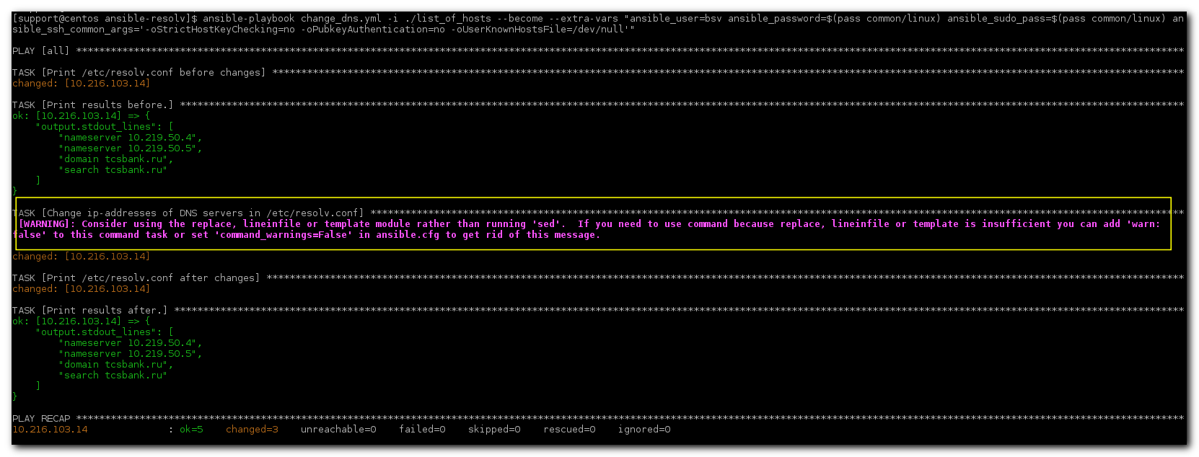

#
# Now - much better.
#
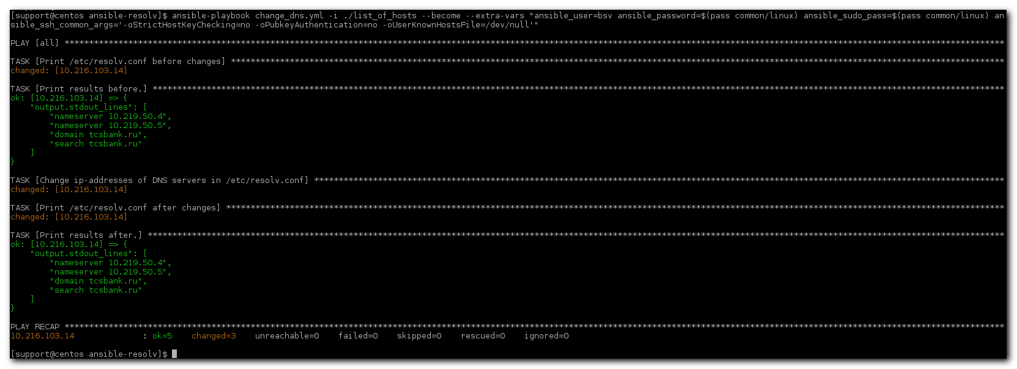

[support@centos ansible-resolv]$ ansible-playbook change_dns.yml -i ./list_of_hosts --become --extra-vars "ansible_user=bsv ansible_password=$(pass common/linux) ansible_sudo_pass=$(pass common/linux) ansible_ssh_common_args='-oStrictHostKeyChecking=no -oPubkeyAuthentication=no -oUserKnownHostsFile=/dev/null'"

[support@centos ansible-resolv]$ cat change_dns.yml
---
- hosts: all
gather_facts: false

tasks:
- name: Print /etc/resolv.conf before changes
shell: 'cat /etc/resolv.conf'
ignore_errors: yes
register: output

- name: Print results before.
debug: var=output.stdout_lines

- name: Change ip-addresses of DNS servers in /etc/resolv.conf
# shell: 'echo #### ; hostname ; echo #### ; find /etc/sysconfig/network-scripts/ -name ifcfg-\* -exec echo \; -exec echo {} \; -exec cat {} \;'
shell: 'sed -i -e "s/10.216.40.4/10.219.50.4/" -e "s/10.216.42.5/10.219.50.5/" /etc/resolv.conf'
ignore_errors: yes
register: output
args:
warn: false

- name: Print /etc/resolv.conf after changes
shell: 'cat /etc/resolv.conf'
ignore_errors: yes
register: output

- name: Print results after.
debug: var=output.stdout_lines
...

[support@centos ansible-resolv]$

https://docs.ansible.com/ansible/latest/modules/shell_module.html

